**Turorial Open Project-khachuynguyen0**

**-Step 1: Choose a folder to save REPO**

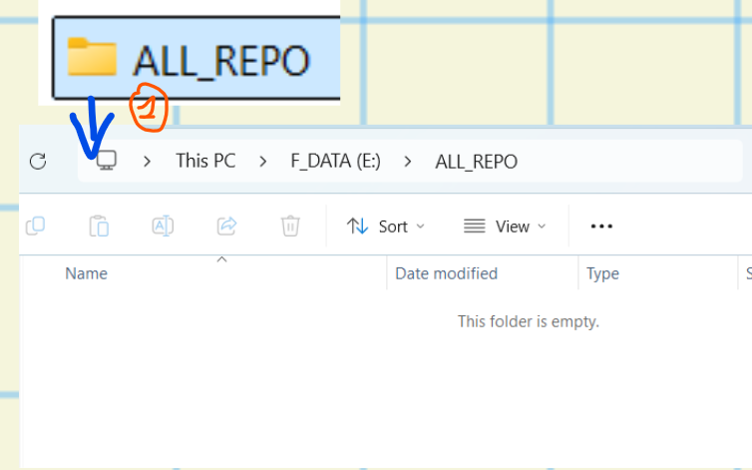

**-Step 2: Open cmd/PowerShell, then copy->past, Open project**

git clone https://github.com/khachuynguyen0/project-01-frontend-the-band-website-clone.git

